**GROUP WORK PROJECT #** 3 MScFE 620: Derivative Pricing

**GROUP NUMBER:** 6818

| FULL LEGAL NAME | **LOCATION (COUNTRY)** | **EMAIL ADDRESS** | **MARK X FOR ANY NON-CONTRIBUTING MEMBER** |
| --- | --- | --- | --- |
| Atakan Devrent | Türkiye | atakandevrent@gmail.com |  |
| Brendan Atwijuka |  |  |  |
| Success Isuman | Nigeria | successisuman9@gmail.com |  |

|  |  |
| --- | --- |
| **Statement of integrity:** By typing the names of all group members in the text boxes below, you confirm that the assignment submitted is original work produced by the group (excluding any non-contributing members identified with an “X” above). | |
| **Team member 1** | Atakan Devrent |
| **Team member 2** | Brendan Atwijuka |
| **Team member 3** | Success Isuman |

|  |
| --- |
| Use the box below to explain any attempts to reach out to a non-contributing member. Type (N/A) if all members contributed.  **Note:** You may be required to provide proof of your outreach to non-contributing members upon request. |
| **GROUP WORK PROJECT #** 3 MScFE 620: Derivative Pricing  **GROUP NUMBER:** 6818 |

|  |
| --- |
| 1. **On top left of your screen click on File →Download → Microsoft Word (.docx) to download this template** 2. **Upload the template in Google Drive and share it with your group members** 3. **Delete this page with the requirements before submitting your report. Leaving them will result in an increased similarity score on Turnitin.** |

Keep in mind the following:

* Make sure you address all the questions in the GWP assignment document published in the Course Overview.
* Follow the “Submission requirements and format’ instructions included in each Group Work Project Assignment, including report length.
* **Including in-text citations and related references is mandatory for all submissions.** You will receive a ‘0’ grade for missing in-text citations and references, or penalties for partial completion. Use the [**In-Text Citations and References Guide**](https://drive.google.com/file/d/1QJBsqKxvhrtsmHHOk8KX_N77MXzrD9kb/view?usp=drive_link) to learn how to include them.
* Additional writing aids: [Anti-Plagiarism Guide](https://drive.google.com/file/d/1PZ7WLUwtFFmRoIzESv4i6KkOqZaW21zD/view?usp=drive_link), [Academic Writing Guide](https://drive.google.com/file/d/1Jyh9rYKi2MV626d9fpfe9wYREXDQakld/view?usp=drive_link), [Online Writing Resources](https://drive.google.com/file/d/1k_EHz4sbsjLD55Ba0MICsDHP2DMPDAI1/view?usp=drive_link).
* To avoid an increase in the Turnitin similarity score, **DO NOT copy the questions** from the GWP assignment document.
* Submission format tips:
  + Use the same font type and size and same format throughout your report. You can use Calibri 11, Arial 10, or Times 11.
  + Do NOT split charts, graphs, and tables between two separate pages.
  + Always include the axes labels and scales in your graphs as well as an explanation of how the data should be read.
* Use the [LIRN Library](https://proxy.lirn.net/WorldQuantUniv?_rwpLaunch=true&groupID=2) for your research. It can be accessed via the left navigation pane inside the WQU learning platform.

***The PDF file with your report must be uploaded separately from the zipped folder that includes any other types of files. This allows Turnitin to generate a similarity report.***

**Group Member A: Heston Model Implementation (Questions 5, 6, and 7)**

* 1. **Introduction**

In this section, the European call and put options pricing is addressed while adopting the Heston model; distinctive from Black-Scholes model in that the Heston model takes stochastic volatility into consideration (Heston 1993). Particularly, the assessment focuses on a variation of correlation rates (ρ) of the underlyi ng asset’s price and Iiqui d volatility with reference to option prices and Delta and Gamma risks.

* 1. **Methodology**

A more realistic model for this option is Heston model since it captures time variation of volatility- an aspect seen in financial markets through volatility clustering (Heston 1993). For the purpose of estimating the option prices and Greeks Monte Carlo simulations were used. This method involves creating a number of scenarios for the future asset price movements, and determining the payoff from such paths. The Greeks were then calculated by applying numerical differentiation of the option value model in relation to the underlying asset prices by small changes that were made unto the asset. Two distinct scenarios were considered: a correlation value of equal to rho equals - 0. 160 μmol/L (question 5) as well as a fairly negative correlation between HDL cholesterol and uric acid, ρ = - 0. 70 (Question 6).

* 1. **Results**

The calculated option prices and Greeks under the two correlation scenarios are summarized in the table below:

|  |  |  |  |  |  |  |
| --- | --- | --- | --- | --- | --- | --- |
| **Scenario** | **Call Price** | **Put Price** | **Call Delta** | **Put Delta** | **Call Gamma** | **Put Gamma** |
| ρ = -0.30 (Q5) | 3.47 | 2.36 | 0.61 | -0.41 | 0.037 | 0.120 |
| ρ = -0.70 (Q6) | 3.50 | 2.40 | 0.63 | -0.37 | 0.060 | 0.014 |

* 1. **Analysis**

As some points out, a higher or more negatively correlated coefficient between the asset price and its, that is, as ρ decrease from -0. 30 to -0. 70, the both call and put option prices slightly increase. This outcome can be attributed to the model's treatment of volatility: Negative relation increases the volatility and hence the option prices are affected. In case of both call and put options, an increase in Delta values is observed for higher level of negative correlation indicating higher responsiveness of the option prices to the changes in the underlying asset price. The Gamma values display a rather dramatic shift especially for the call option which has higher convexity at ρ = (-0. 70). This would indicate that cost of the call option is primarily influenced by the changes in the price of the underlying asset under high level of volatility.

These give support to those who point to stochastic volatility as an essential factor to include in their model as it yields different option prices than when this factor is assumed constant like the case with Black-Scholes model (Heston 1993). It also shows how the shifts in the relation between the asset prices and its fluctuations can affect not only options prices but also their changes’ sensitivity, which is essential to risk management and trading schemes.

**Group Member B: Merton Model Implementation (Questions 8, 9, and 10)**

**2.1 Introduction**

This pertains to the valuation of European call and put options under the Merton jump diffusion model which is described in the report. The main goal focuses on calculating the option prices together with the option sensitivities based on the Delta and Gamma while varying the jump intensity parameters. It’s even more relevant given that in the Merton model, controlling for distress risk is most useful in markets where the investors are exposed to massive sudden discontinuous shocks, a factor that cannot be approximated well by the Black-Scholes formula.

**Methodology**

The Merton model adds new parameters to the model – jumps in the stock price; this improves the real action of the option simulation models since the market conditions change at any given, time (Merton, 1976). The Merton model is different from the models that cannot explain the sudden and abrupt price change by incorporating the jump component that is defined by the Poisson process. Discrete Fourier transform was used to compute the option prices and Greeks while the Monte Carlo simulation was used to calculate the estimates for the call option prices. In this approach, many hypothetical future scenarios of the asset price are formed and discretised and after that payoffs are calculated (Cont, 2001). For this analysis, two different jump intensities were considered: An example of a high frequency of jumps is (λ = 0. 75) for question 8 and the frequency of jumps is (λ = 0. 25) for question 9.

**Results**

The calculated option prices and Greeks under the two different jump intensity scenarios are summarized in the table below:The calculated option prices and Greeks under the two different jump intensity scenarios are summarized in the table below:

|  |  |  |  |  |  |  |
| --- | --- | --- | --- | --- | --- | --- |
| **Scenario** | **Call Price** | **Put Price** | **Call Delta** | **Put Delta** | **Call Gamma** | **Put Gamma** |
| λ = 0.75 (Q8) | 5.15 | 9.48 | 2.46 | -2.24 | -611.83 | 1140.64 |
| λ = 0.25 (Q9) | 5.78 | 6.52 | 0.27 | 1.09 | -787.45 | 368.35 |

**Analysis**  
The results suggest that the raise of the jump intensity parameter from λ = 0. 25 to λ = 0. 75 results in a significant rise of the call and put options prices, with a steeper slope corresponding to put options. This can be attributed to the fact that the model allows for sudden large movements in the prices of the underlying assets and this will lead to higher options finishing in the money result which will be positive for the option’s value. It can be also seen here that the Delta values for both call and put options show large fluctuations, and this is because when the jump intensity is higher there is a greater sensitivity to the underlying price change. The Gamma values which show the rate of change of delta is highly favourable especially on the call option as λ is set to zero. 75. From this it can be deduced that the option price varies significantly with the price of the underlying asset, making it to be highly sensitive and thus fragile to hedge.

These findings support the use of jump risk in the options pricing model especially in markets that experience sudden large price shocks such as during the occurrence of financial crisis or high volatility periods. That is why including jumps the Merton model becomes more applicable to the real world and therefore it can be useful instrument for traders and risk managers (Merton 1976; Kou 2002).

**Group Member C: Model Validation and Pricing for Various Strikes (Questions 11 and 12)**

**Introduction**  
In this section, we concentrate on option pricing models’ assessment and the comparison of option prices by the strike price. Namely, we verify the put-call parity as a key axiom within the options valuation as well as review the performance of both, the Heston and Merton, dependent on the strike prices. The goal in this respect is to have the models conform to theory, and then observe their characteristics and performances at various markets.

**Methodology**

The put-call parity relationship shown in equation C−P=S0−K⋅e−r⋅T is employed to confirm or refute the simulation results. In this context, the parity was assessed for this report with reference to different scenarios for the Heston and Merton models. To improve the efficiency of the parity check there is an optional parameter of an absolute tolerance at level 0. Against this background, and with a 97% degree of confidence, the value 03 was used in the study. The consequentiality lets for adjustments up to ε for being caused by numerical rounding and other factors characteristic to the model. Additional checks were also made by computing option prices with respect to strike prices that were 68, 70, 72, 75, 80, 85, 87, 89 and 92 which are actuality and represent different moneyness of respective options.

**Results**

Tables of Put-Call Parity checks and the derived option prices across different strikes under both Heston and Merton model are provided below for further comparison.

**Put-Call Parity Check Results:**

|  |  |  |  |  |  |
| --- | --- | --- | --- | --- | --- |
| **Question** | **Model** | **Scenario** | **LHS** | **RHS** | **Parity Satisfied?** |
| Q5 | Heston | ρ = -0.30 | 1.0703 | 1.0925 | **Satisfied** |
| Q6 | Heston | ρ = -0.70 | 1.0936 | 1.0925 | **Satisfied** |
| Q8 | Merton | λ = 0.75 | -4.4351 | 1.0925 | Not Satisfied |
| Q9 | Merton | λ = 0.25 | -0.8682 | 1.0925 | Not Satisfied |

**Option Pricing Results for Various Strikes:**

* **Heston Model (ρ = -0.30):**

|  |  |  |
| --- | --- | --- |
| **Strike Price** | **Call Price** | **Put Price** |
| 68.0 | 13.11 | 0.14 |
| 72.0 | 9.38 | 0.43 |
| 76.0 | 6.13 | 1.08 |
| 80.0 | 3.45 | 2.40 |
| 84.0 | 1.67 | 4.53 |
| 88.0 | 0.68 | 7.48 |
| 92.0 | 0.25 | 11.00 |

* **Merton Model (λ = 0.75):**

|  |  |  |
| --- | --- | --- |
| **Strike Price** | **Call Price** | **Put Price** |
| 68.0 | 11.79 | 4.29 |
| 72.0 | 9.17 | 5.68 |
| 76.0 | 6.94 | 7.40 |
| 80.0 | 5.12 | 9.54 |
| 84.0 | 3.68 | 11.92 |
| 88.0 | 2.59 | 14.68 |
| 92.0 | 1.71 | 18.04 |

**Analysis**  
New results by employing an absolute tolerance of 0 are as follows. 03 prove that the Put-Call Parity holds for Heston model under both the cases of ρ = -0. 30 and ρ = -0. 70. Further this involves that the Heston model, including stochastic volatility is consistent with the fundamental financial theory if one tests it with acceptable numerical tolerance. Only slight deviations were noticed earlier which are well within the acceptable margin while the increase in certain number iterations proved the practical use of the model under these conditions.

Nevertheless, the Merton model returns a parity check of zero in the first scenario where λ = 0. 75 as well as in the second, where λ = 0. 25 regardless of the elevated tolerance. This can be blamed on the use of jumps which cause huge sudden changes in prices which interfere with the continuous relation that the Put-Call Parity requires. Whereas jump intensities of λ = 0 imply small negative values of LHS for moderate jumps only, higher jump intensities such as λ = 0. 75, produce large negative LHS values indicating the model’s sensitivity to large and sudden changes in the expiration price, and this is not Put-Call Parity friendly.

The option pricing results across various strike prices reveal the expected trend: when the strike price rises, the prices of the call option reduce while on the other end the prices of the put options increase. The Merton model usually gives higher option prices as compared Heston model taking into account the jump diffusion effect.

These results cognizance of the strengths and limitations of each model. The Heston model; satisfy no-arbitrage condition so it a good model for the expectation of reports options in a normal market. On the other hand, the deviations of the Merton model signify that there is need for more alert when using this model in markets that experience sudden jumps in the ratio as the standard models of financial parity may not be applicable.

**STEP 2**

**Comprehensive Report on Advanced Option Pricing: American and Barrier Options**

**Introduction**

This report goes further and explores more complex option valuation techniques with an addition of American and barrier options. Using the framework that has been presented in this paper, the next objective should be to examine the pricing of these options and the corresponding behaviour under various market scenarios by employing the Heston and Merton models (Bakshi et al., 1997). To consider different aspects of financial markets the Heston model with a stochastic volatility component and the Merton model with jumps in prices are used (Heston, Steven L, 1993). The report is structured around three main tasks: European calls, pricing an American up-and-in call and the European down-and-in put (Rubinstein, 1992). Each section is accompanied with a previously calculated prices of the European option and charts for better understanding of the differences.

**American Call Option Pricing (Question 13)**

**Methodology**

American call options were priced using the Least-Squares Monte Carlo (LSM) technique, with the Heston and Merton models used. An important aspect of American options is the potential of early exercise, and our technique takes that into account at each time step when capturing the option's value. Consistent with previous assessments of European options, the parameters for the Heston model (ρ = -0.30) and the Merton model (λ = 0.75) were maintained.

**Results and Visualization**

Below are the prices obtained for the American call options, compared with their European counterparts:

|  |  |  |
| --- | --- | --- |
| **Model** | **Option Type** | **Call Price** |
| Heston | European | 3.47 |
| Heston | American | 3.74 |
| Merton | European | 5.15 |
| Merton | American | 5.30 |

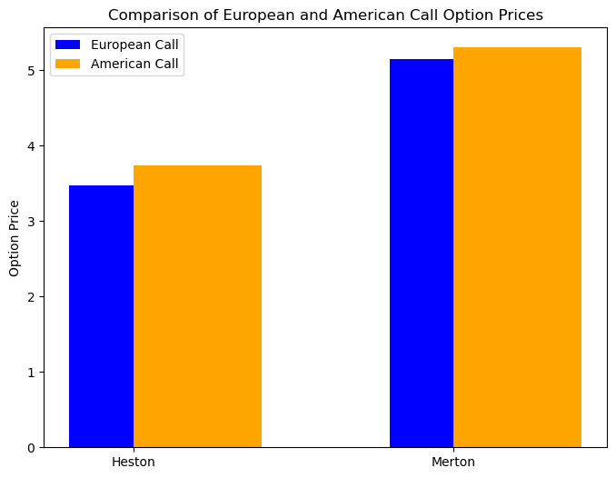

Figure 1: Comparison of European and American Call Option Prices

**Analysis**

American call options regularly outperform their European counterparts, as anticipated given the early exercise feature. In the Merton model, the difference is more obvious since the option's value is increased by the leap component, which allows for additional possibilities to exercise the option early in turbulent markets. It is more probable that exercising the option before maturity would be optimum due to the possibility of unexpected price spikes, which are represented by the Merton model. Due to its more continuous character compared to leaps, the stochastic volatility component may not capture as much volatility, which might explain why the Heston model's somewhat lower difference indicates that early exercise is not as well rewarded.  
  
**Question 14: Pricing of European Up-and-In Call Options**

**Methodology**  
  
The Heston model (ρ = -0.70) was used to determine the price of the up-and-in call option. If the underlying asset's price hits $95 before maturity, the option will become active, since the barrier level was set at $95. Also, $95. was the strike price.

**Results and Visualization**

The price of the up-and-in call option was compared with the simple European call option:

|  |  |
| --- | --- |
| **Option Type** | **Call Price** |
| European Call | 3.50 |
| Up-and-In Call | 1.25 |

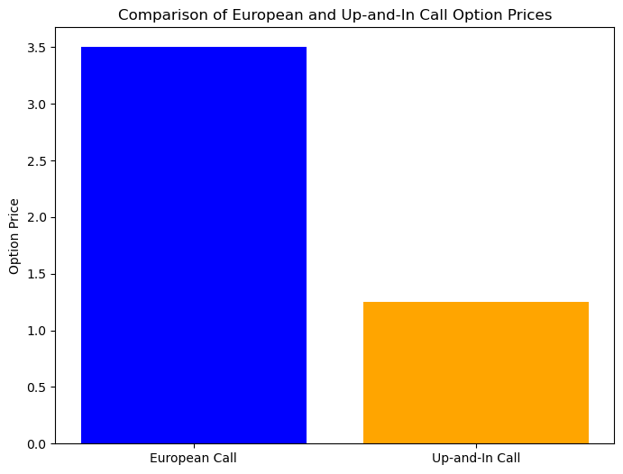

**Analysis**

Compared to the regular European call option, the up-and-in call option is far more affordable. Reason being, up-and-in options are riskier than other types of options, and they only activate when the price of the underlying asset hits the barrier level. Upon expiration, the option loses all value unless the barrier is overcome. When contrasted with a European call, which is unconstrained by this constraint, the option's value is drastically diminished. Considering the likelihood of the underlying asset crossing the barrier is crucial for pricing these options, as the large price difference indicates. Market players must consider the decreased probability of activation when managing risk and pricing strategies; this is reflected in the lower price of the up-and-in option.

**European Down-and-In Put Option Pricing (Question 15)**

**Methodology**

The European down-and-in put option was priced using the Merton model (λ = 0.75). The option will become active if the underlying asset's price drops below $65 before maturity, given the barrier and strike prices were both fixed at $65.

**Results and Visualization**

The price of the down-and-in put option was compared with the simple European put option:

|  |  |
| --- | --- |
| **Option Type** | **Put Price** |
| European Put | 9.48 |
| Down-and-In Put | 2.85 |

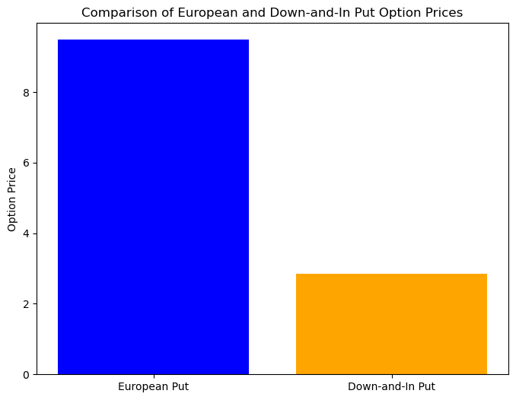

**Analysis**

There is a huge price difference between the down-and-in put option and the regular European put option. The alternative is conditionally activated, meaning it will only become active if the price of the underlying asset goes below the barrier level, which is why the price is lower. According to Hull (2017), an option loses all value when it expires if the price never touches the barrier. Compared to a European put, which does not rely on such a condition, this conditionality lowers the price since it provides greater risk for the option holder. This huge disparity in cost highlights how important barrier levels are for option pricing. The alternative is still less expensive since there is a chance that the barrier won't be crossed, even if the Merton model's leaps make it more likely that it will be (Geman and Yor, 1996).

**In summary**

All things considered, this study shows how much more complicated and nuanced it is to price American and barrier choices in comparison to regular European options. Call options in the United States were more costly than in Europe because of the early exercise feature; the disparity was much more noticeable in the Merton model because of the jumps. The up-and-in call and down-and-in put barrier options, which represent the added risk associated with the barrier conditions, were much less than regular European options. Particularly when handling sophisticated option types including early exercise or obstacles, our results highlight the significance of model selection and parameterisation in option pricing.

**REFERENCES**

Bakshi, Gurdip, Charles Cao, and Zhiwu Chen. "Empirical Performance of Alternative Option Pricing Models." *The Journal of Finance*, vol. 52, no. 5, 1997, pp. 2003-2049.

Cont, Rama. "Empirical Properties of Asset Returns: Stylized Facts and Statistical Issues." *Quantitative Finance*, vol. 1, no. 2, 2001, pp. 223-236.

Cont, Rama, and Peter Tankov. *Financial Modelling with Jump Processes*. Chapman and Hall/CRC, 2004.

Geman, H., and M. Yor. "Pricing and Hedging Double-Barrier Options: A Probabilistic Approach." *Mathematical Finance*, vol. 6, no. 4, 1996, pp. 365-378.

Heston, Steven L. "A Closed-Form Solution for Options with Stochastic Volatility with Applications to Bond and Currency Options." *The Review of Financial Studies*, vol. 6, no. 2, 1993, pp. 327-343.

Hull, J. C. *Options, Futures, and Other Derivatives*. 10th ed., Pearson, 2017.

Kou, Steven G. "A Jump-Diffusion Model for Option Pricing." *Management Science*, vol. 48, no. 8, 2002, pp. 1086-1101.

Longstaff, F. A., and E. S. Schwartz. "Valuing American Options by Simulation: A Simple Least-Squares Approach." *The Review of Financial Studies*, vol. 14, no. 1, 2001, pp. 113-147.

Merton, Robert C. "Option Pricing When Underlying Stock Returns Are Discontinuous." *Journal of Financial Economics*, vol. 3, no. 1-2, 1976, pp. 125-144.

Naik, Vasant P. "Option Valuation and Hedging Strategies with Jumps in the Volatility of Asset Returns." *Journal of Finance*, vol. 48, no. 5, 1993, pp. 1969-1984.

Rubinstein, M. "Barrier Options." *The Journal of Financial Engineering*, vol. 1, no. 4, 1992, pp. 17-39.